GLOS: GLOve for Speech Recognition

Alternative Title:Wearable Bi-Directional Communication System for Deaf-Blind People based on Morse code

Aim:
Aim of this project is develop a portable, compact device to help deaf-blind people to communicate with common people based on speech recognition and haptic vibration.

Introduction:
Advancements in Biomedical field provide lot of assistive devices to help deaf people and visually impaired people. When it comes to the subject of deaf-blind people (who losses both hearing and visual ability) availability of such devices are very limited. Tactile signaling and manual alphabets are the most commonly methods used to make the reciprocal communication between the impaired and the surrounding environment possible. Existing devices like MyVox, Sparsha are use braille tactile reading/writing to make communication between two deaf blind users. Assistive systems available in market are high cost and invasive. The proposed system is wearable, non invasive, compact and low cost. It can recognize the speech and convert into Morse code vibrations. Raspberry Pi is used to convert speech into text using microphone and then each text changed to Morse code using raspberry pi. These signals will be sending to micro haptic vibrating motors through GPIO pins of raspberry pi which are attached with user's fingers.

Existing system:
Existing system uses the live speech recognition for deaf-blind people. It improves the communication between deaf-blind and non-impaired people. It uses the speech to text conversion and encoding vibrating techniques to make communication between them.

Proposed system:
Existing system proposed only the one way communication which doesn't mentioned the way impaired people give the reply to non-impaired people. In our proposed system we added feedback device which consist of input buttons. Encoding techniques used in the existing system uses 5 vibrations at the same time which is difficult to practice and to understand. In proposed system, we are using Morse code. It is already used by deaf-blind people, which need not any special training.

Block Diagram:
Speaker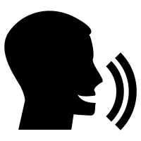
GLOVE

USER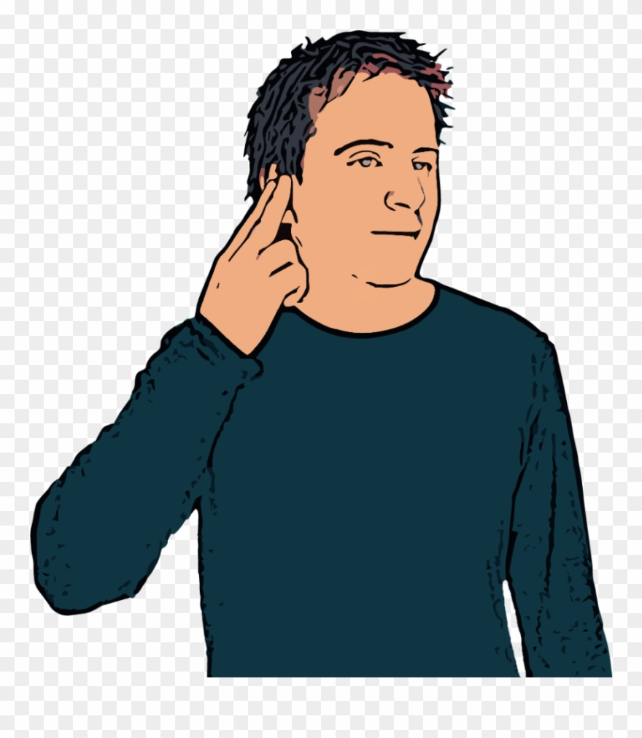
Buttons
Mic

Raspberry Pi
Vibrators
USB Speaker

Speech Input
Text to Speech Conversion
Speech to Morse code conversion
Morse code vibrations output
Button Status
Morse code generation
Morse code to text conversion
Text to speech conversion

Block Diagram Description:
In this Block Diagram, Five buttons and one microphone used as input devices and five haptic motors and one speaker used as output devices to the controller. Here, Raspberry Pi is used as controlling unit. Microphone used to get voice input from normal people and button used to get input from impaired people. When the speech to text conversion completed it gives to the encoding section and gives the user understandable vibrating output via haptic motors. Depending on the button status message of user conveyed to normal people via speaker.

Requirements:
Hardware requirements:
- Microphone
- Buttons*4
- Toggle Switch
- Vibrators*3
- Raspberry Pi
- Speaker
Software requirements:
- Language : Python
- Compiler : GCC Complier.
- OS : Linux

